Welcome to Web Development
Follow the instructions below to complete each task. Make changes to your code using Visual Studio Code. For each change you make, do not forget to save, then, refresh the web page.
Task 1 – Add instructions for the user. At line 88, write this code into your code.
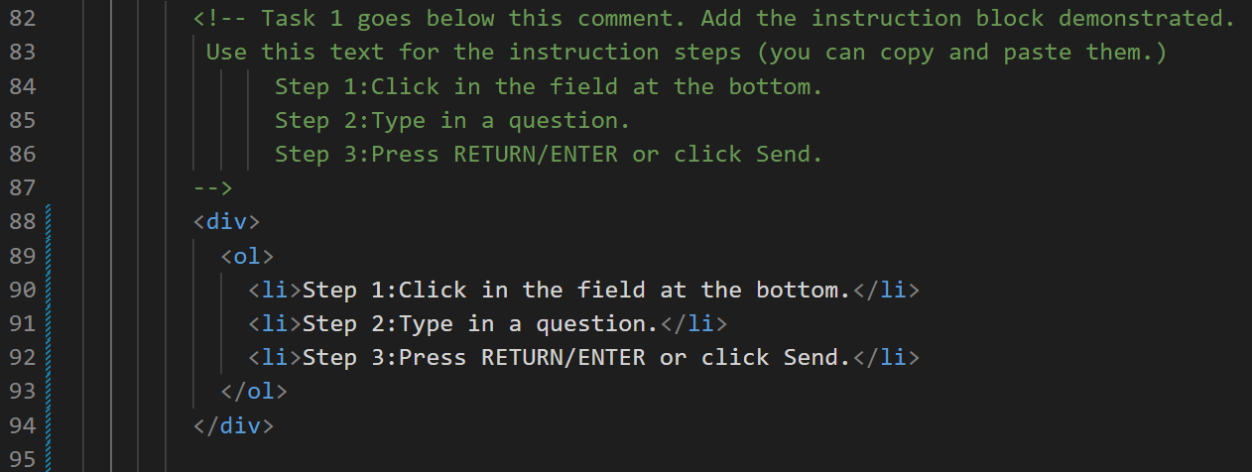
Task 1 Results – Save and Refresh the Web Page
  Figure 1 - Before |  |   Figure 2 - After

Task 2 – Add an icon of a Roaring tiger at line 50
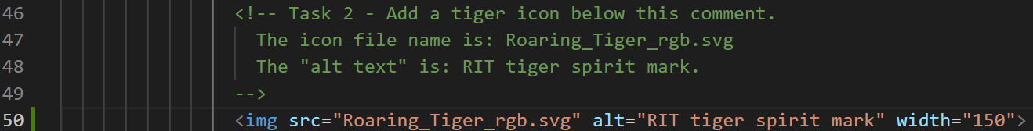
Figure 3 - Before |  |   Figure 4 - After

Task 3 – Add a little spacing at line 88
Figure 5 - Before |  | Figure 6 - After

